Shy Panda



In this project you will make a dancing panda.

It’ll be a shy panda, that will get embarrassed and stop dancing if it sees you looking in through the window.

You’ll train it so that if you cover your eyes, it’ll recognise that you’re not looking and keep dancing.

The idea for this project came from Cassie Evans. You can see her version of it at   
https://codepen.io/cassie-codes/pen/jKaVqo

The panda artwork in this project was by Ed Moffatt from XMPT Games.

This project worksheet is licensed under a Creative Commons Attribution Non-Commercial Share-Alike License

http://creativecommons.org/licenses/by-nc-sa/4.0/

1. Go to <https://machinelearningforkids.co.uk/> in a web browser
2. Click on “**Get started**”
3. Click on “**Try it now**”
4. Click on “**Projects**” on the top menu bar
5. Click the **“+ Add a new project**” button.
6. Name it “shy panda” and set it to learn to recognise “**images**”  
   *If the form asks where to train the model, choose “****on your computer****”*  
   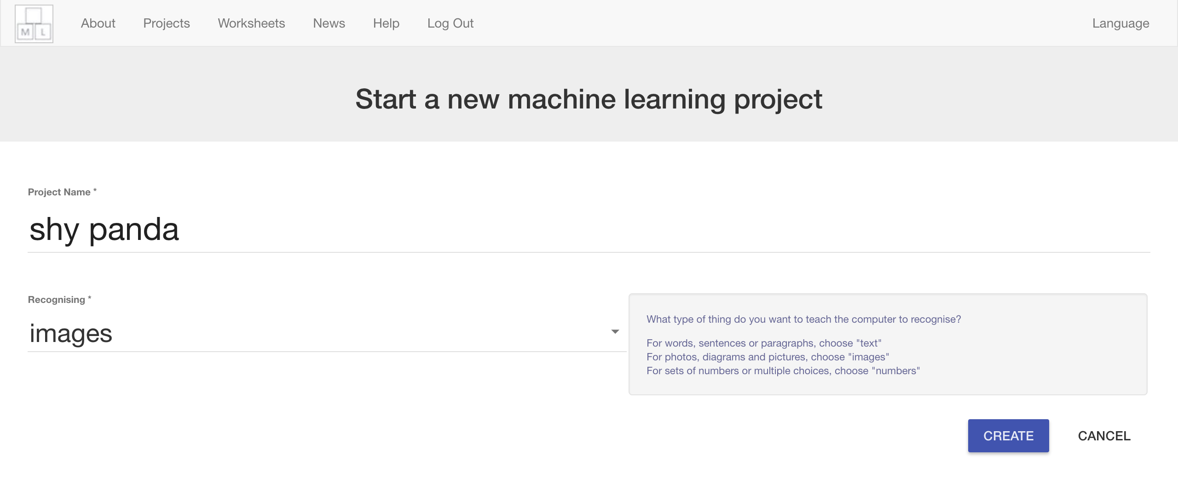
7. Click the “**Create**” button
8. You should see “**shy panda**” in the list of your projects. Click on it.  
   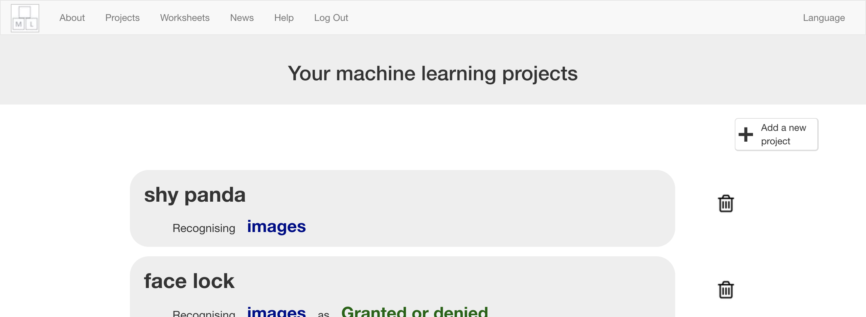
9. Click the **Train** button  
   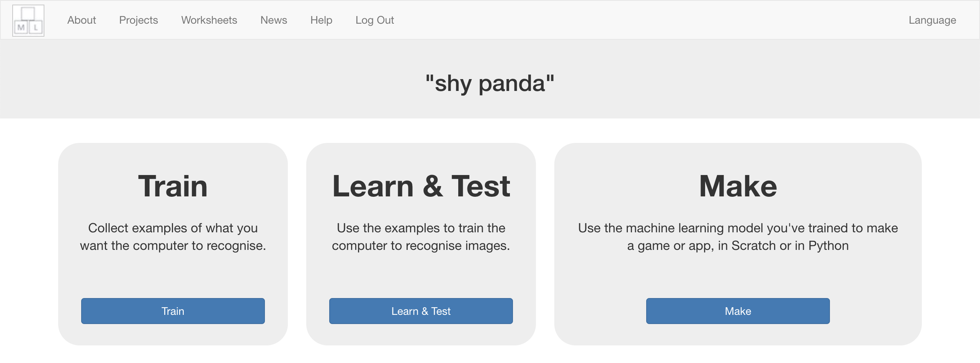
10. Click “**+ Add new label**”  
    
11. Type in “looking”, and press **Add**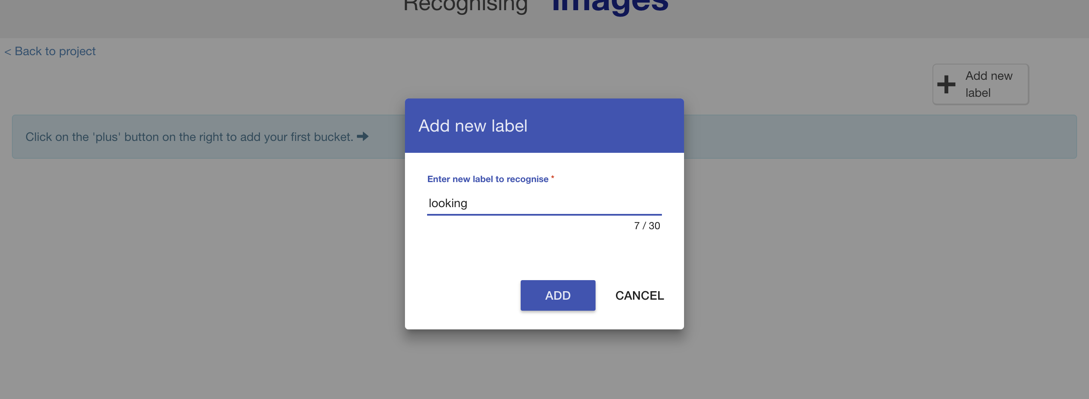
12. Do that again, but this time add “not looking”  
    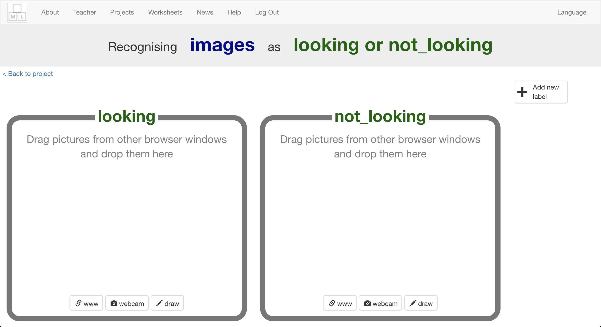
13. Click on the “**webcam**” button in the “not looking” bucket  
    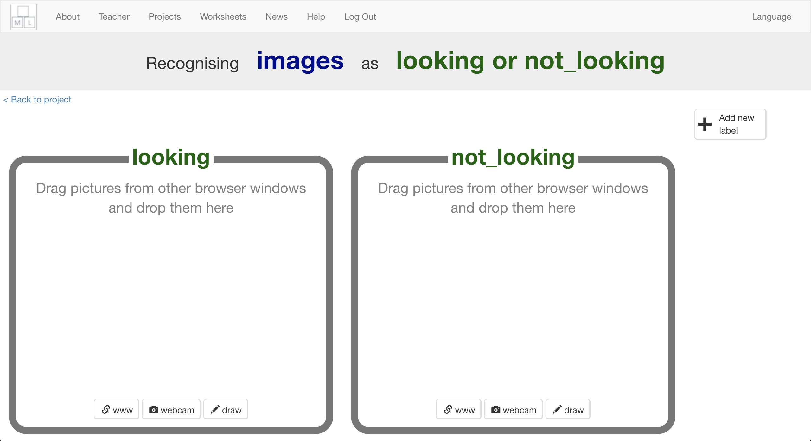
14. Cover your face with your hands, and take a photo   
    *It might be easier if you have a partner to click the “****Add****” button for you!*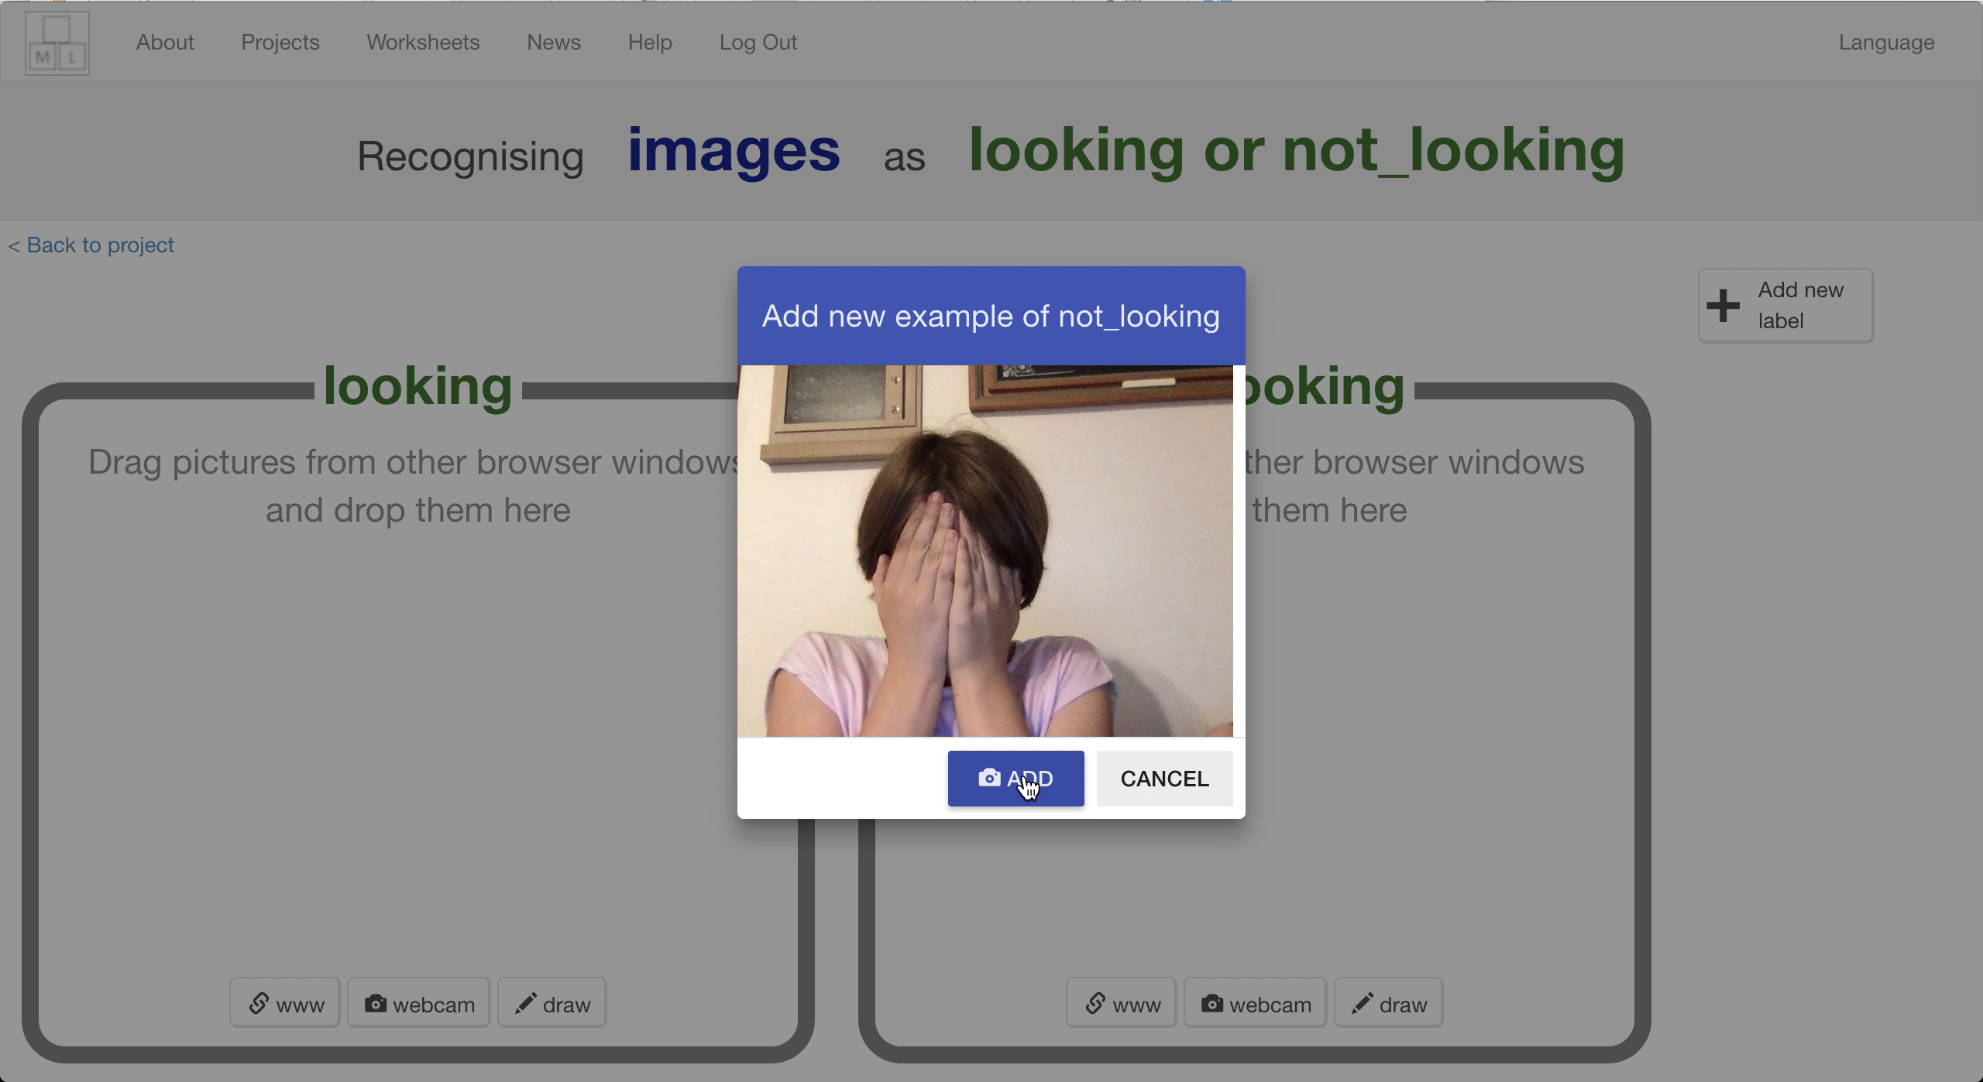
15. Repeat until you’ve got **ten photos** like this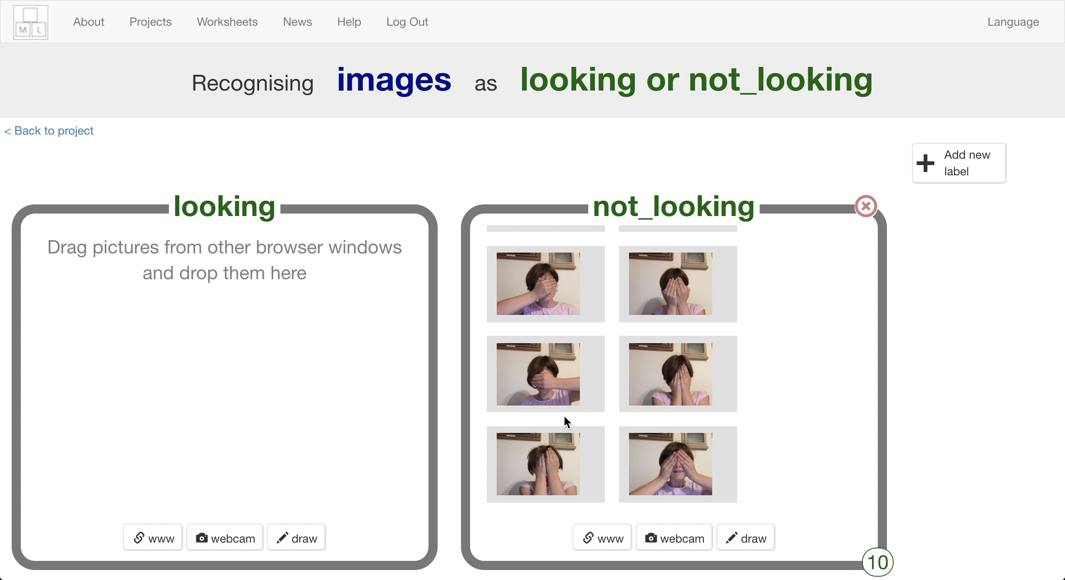
16. Click the “**webcam**” button in the “looking” bucket  
    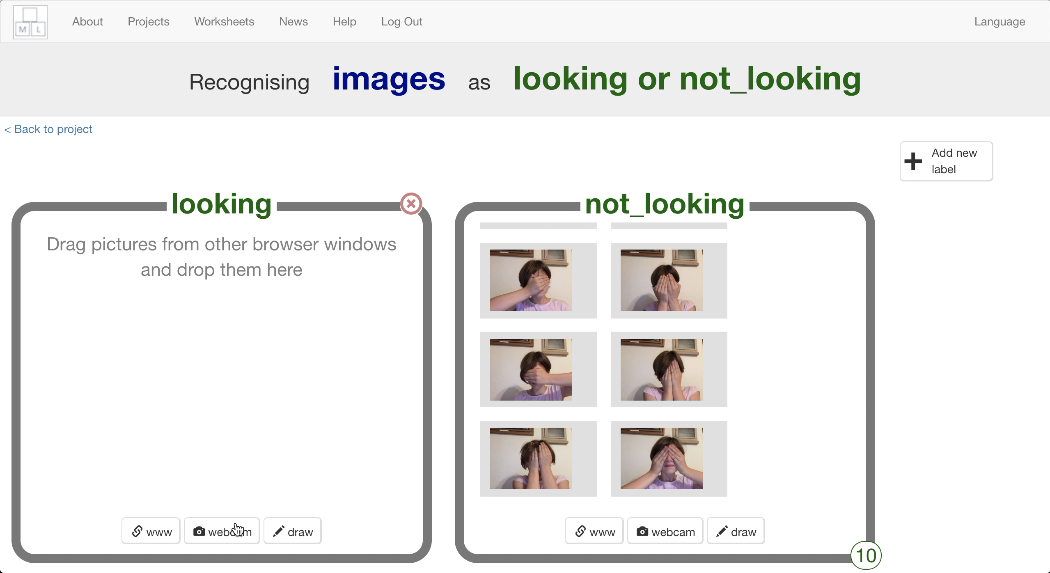
17. Look at the camera and click “**Add**”  
    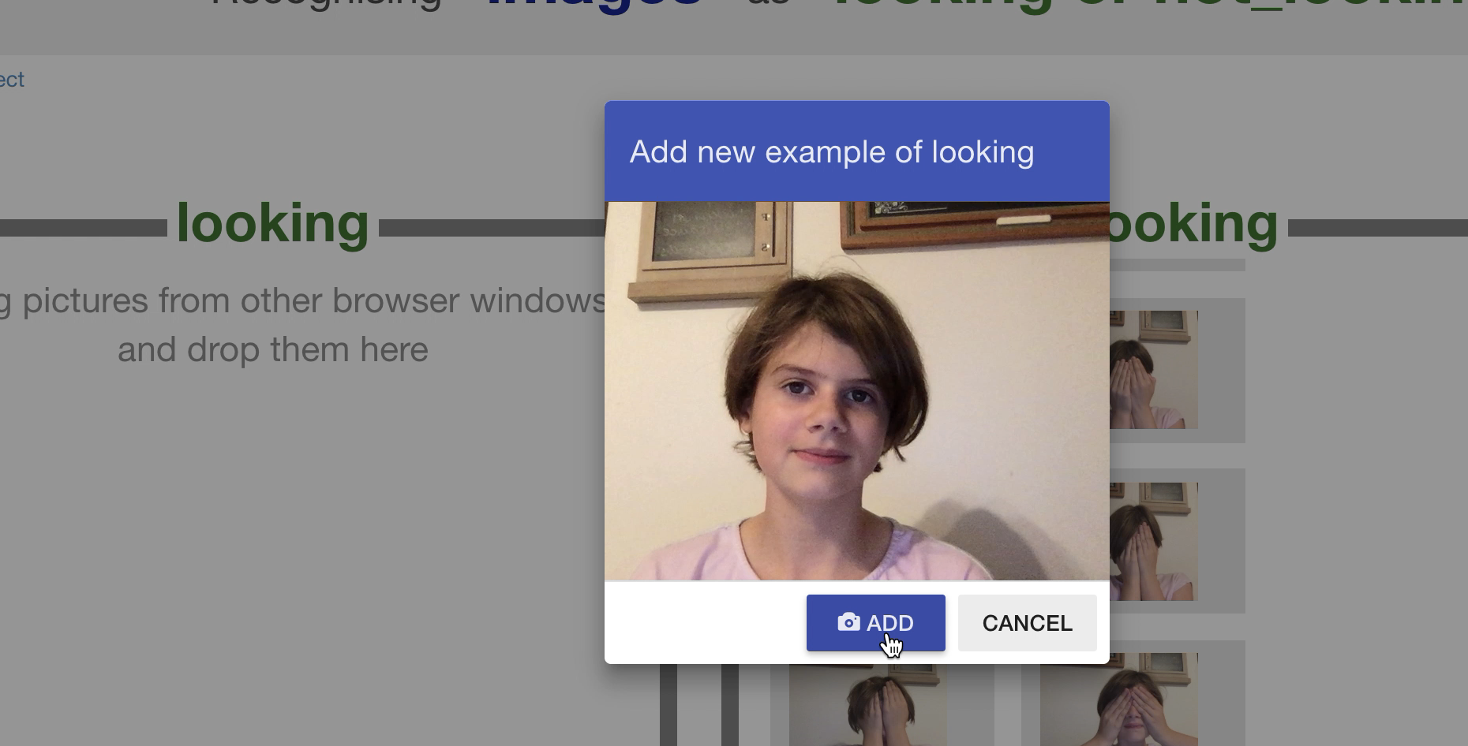
18. Repeat until you’ve got **ten photos** like this  
    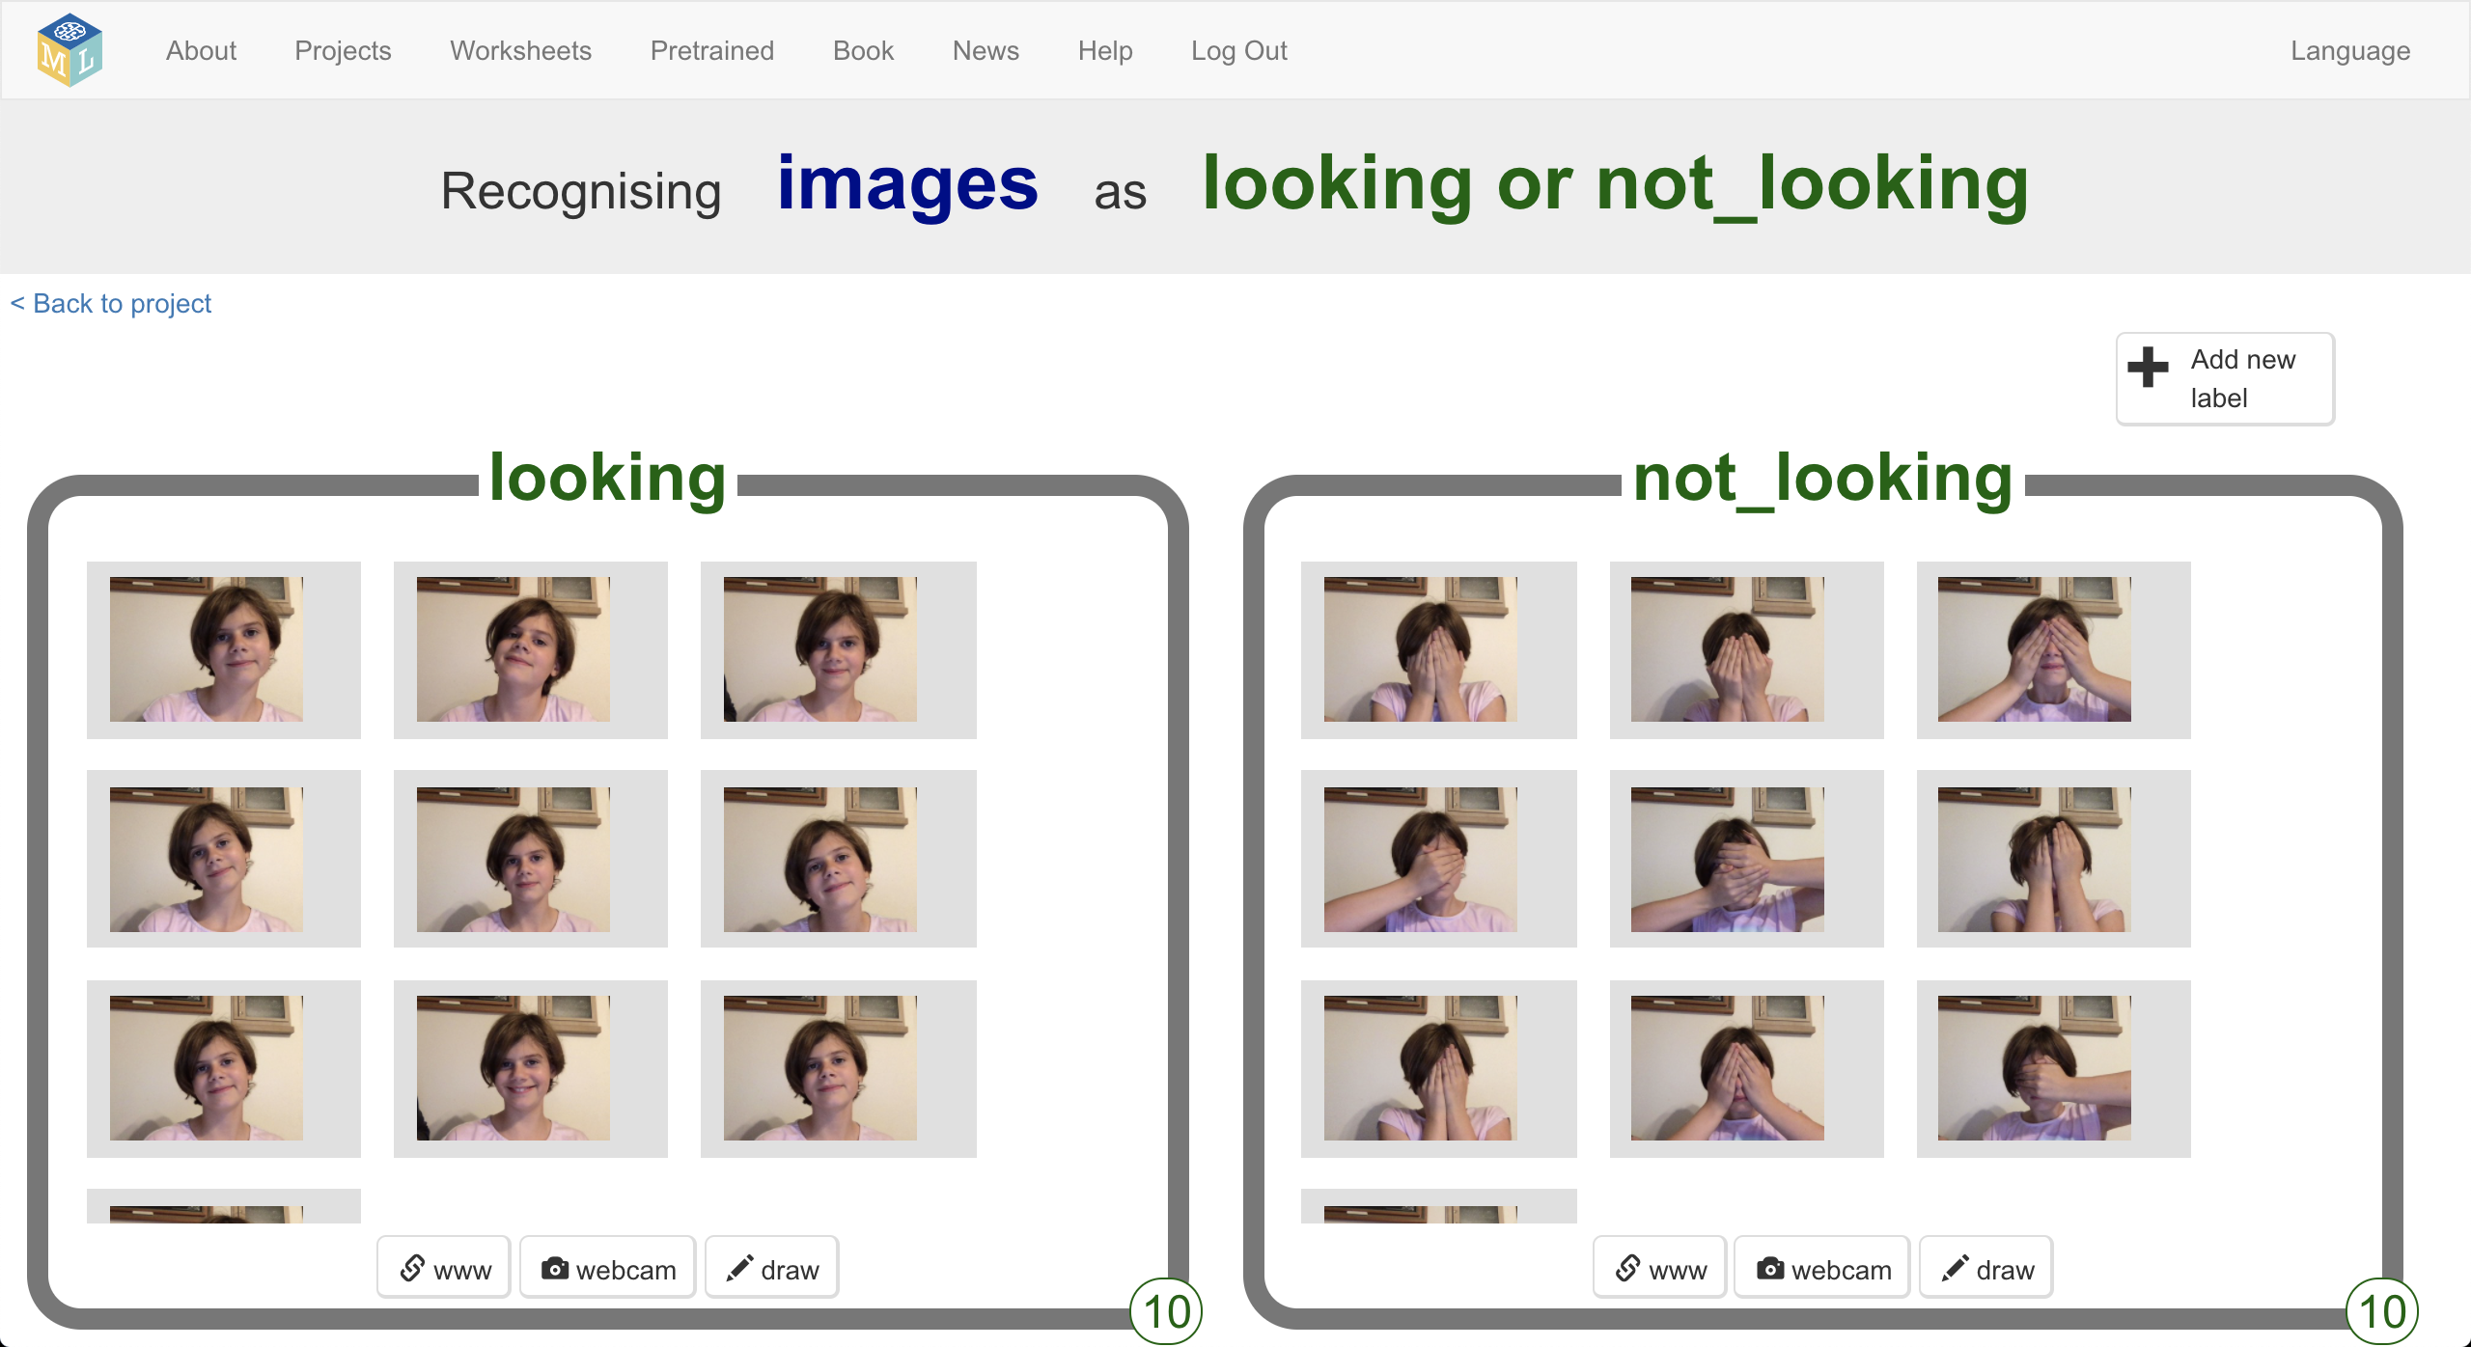
19. Click “**< Back to project**”
20. Click **Learn & Test**
21. Click the “**Train new machine learning model**” button  
    *Wait for the model to train. It should only take a minute.**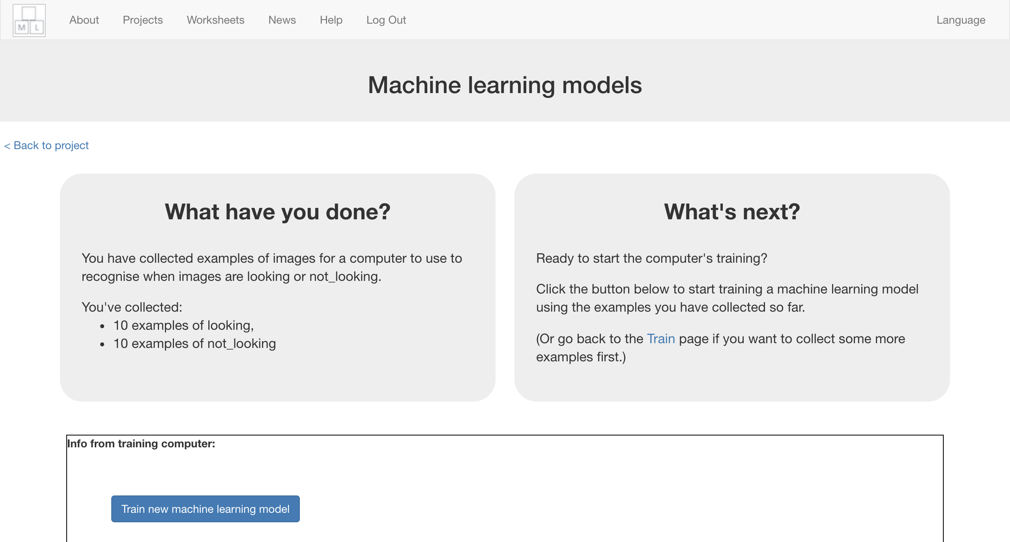*

**What have you done so far?**

You’ve started to train a computer to recognise whether photos of a face and photos of a covered face. You are doing it by taking example photos. These examples are being used to train a machine learning “model”.

This is called “supervised learning” because of the way you are supervising the computer’s training.

The computer will learn from patterns in the shapes from each of the photos you’ve given it. These will be used to recognise new photos.

1. Click “**< Back to project**”
2. Click the “**Make**” button
3. Click “**Scratch 3**”  
   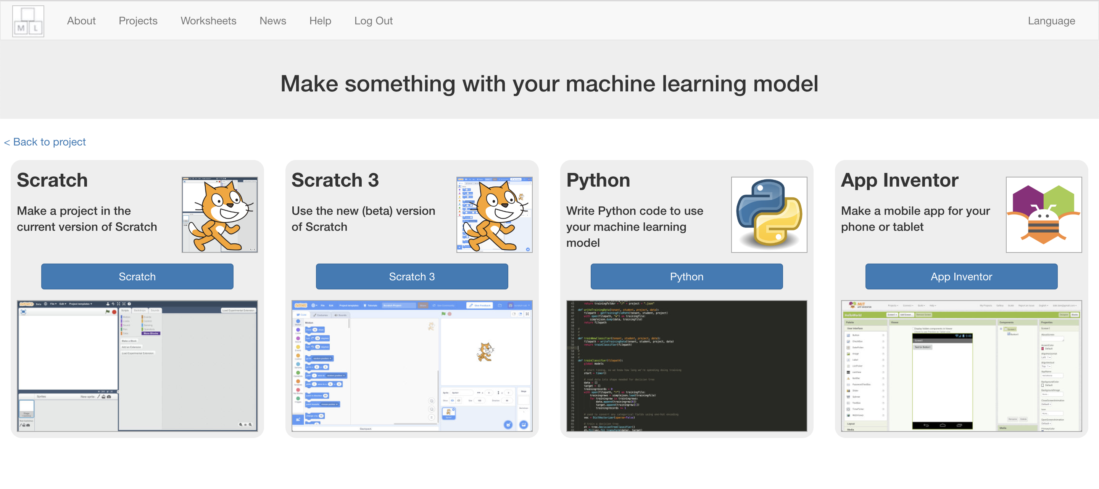
4. Click on “**Open in Scratch 3**”  
   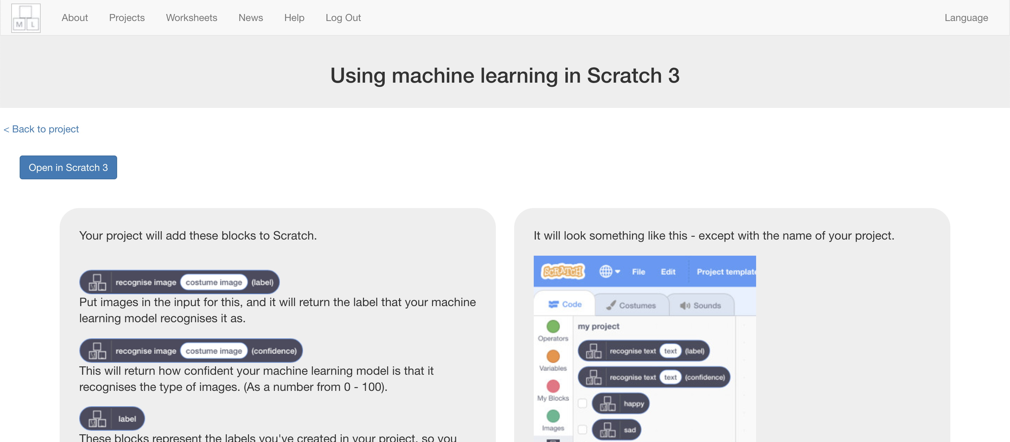
5. Click on “**Project templates**”  
   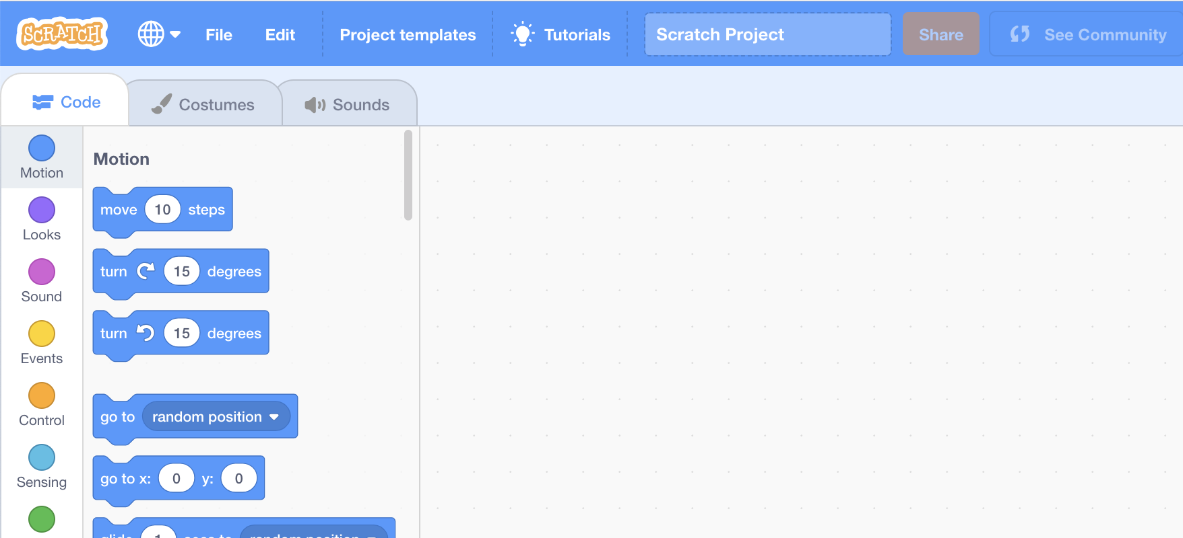
6. Click on the “**Shy Panda**” template  
   *You might need to scroll down to it*
7. Find the “**recognise window**” script in the “**window**” sprite  
   Graphical user interface, application

   Description automatically generated
8. Change the “**recognise window**” script so that it looks like this  
   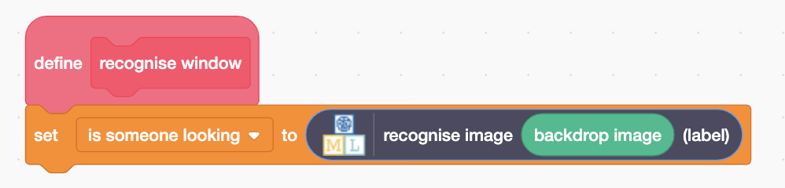
9. Find the “**setup**” script in the “**window**” sprite  
   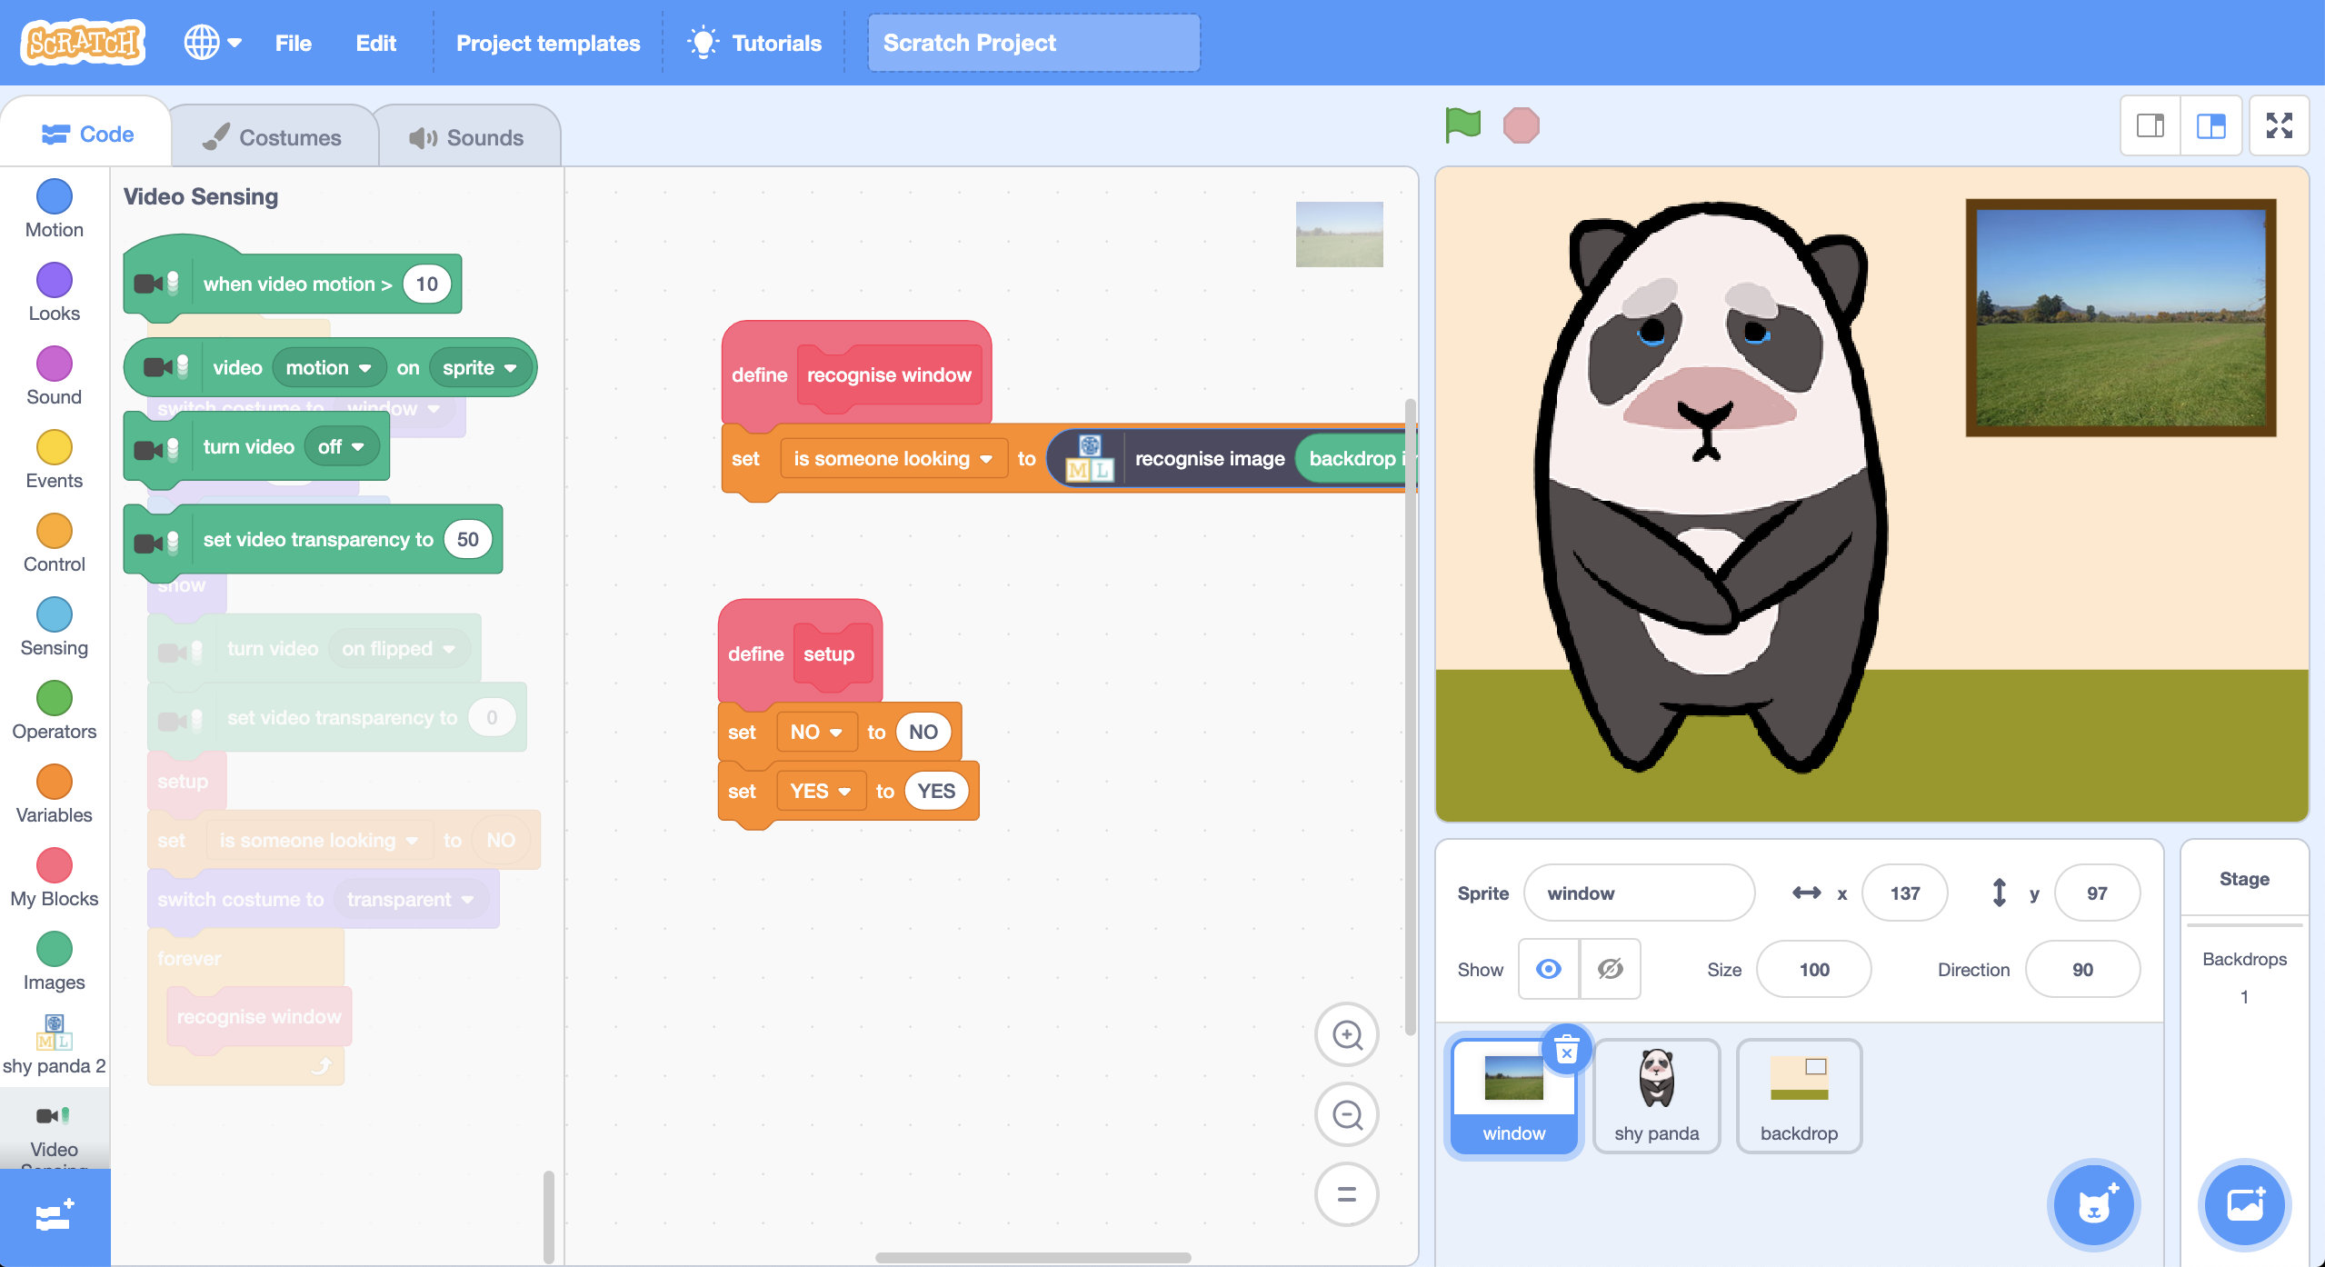
10. Change the “**setup**” script so that it looks like this  
    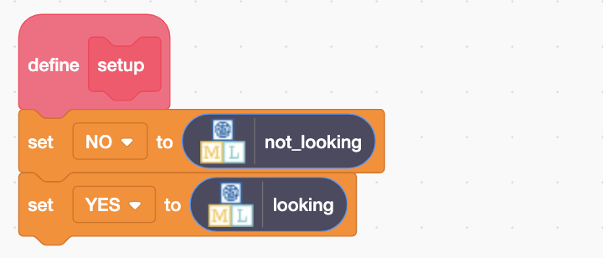
11. Click the **Green Flag** to start the panda dancing
12. You should see yourself in the window in the Scratch project.  
    You might need to move so that your face is visible in the window.  
    *If your machine learning model recognises the view in the window as “looking”, the panda should stop dancing and look embarrassed!*

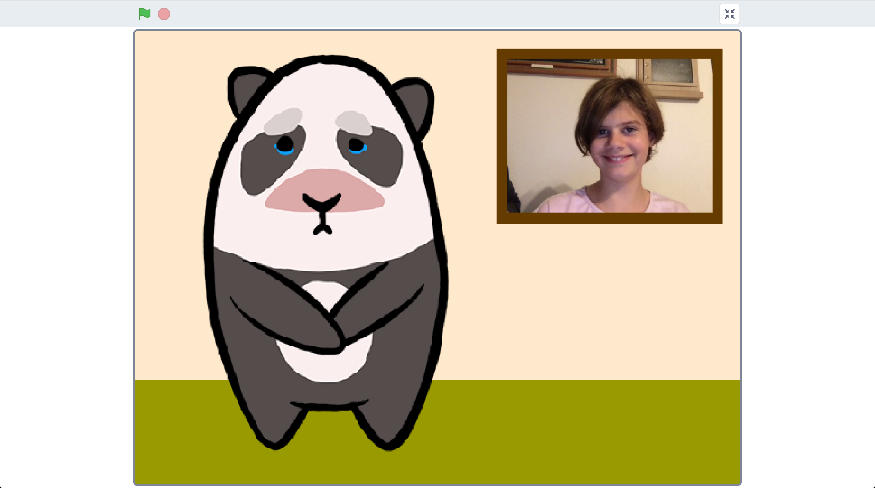

1. Try covering your face.  
   *The panda should start dancing again, as your machine learning model will recognise that you’re not looking.*  
   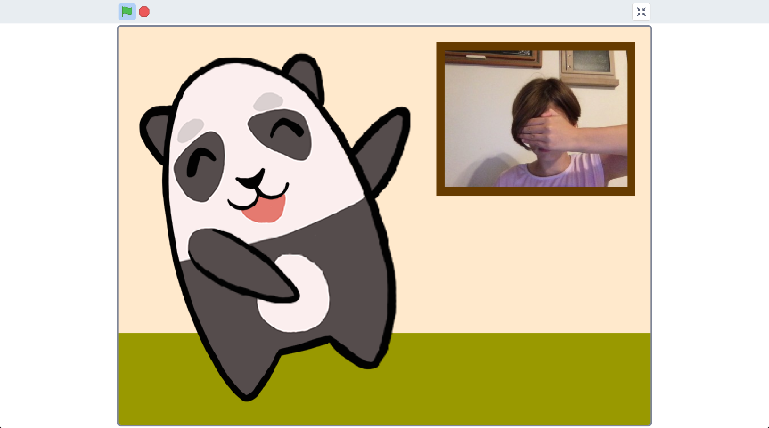

**What have you done?**

You’ve created a shy panda in Scratch that uses machine learning to recognise whether the view at the window is a picture of you looking in.

The machine learning model that you’ve trained is an image classifier, that is able to classify photos as one of two classes – either looking or not looking.

The more examples you give it, the better it should get at recognising whether or not you’re looking at it.

**Ideas and Extensions**

Now that you’ve finished, why not give one of these ideas a try?

Or come up with one of your own?

**Draw your own character**

You don’t have to use the panda in the project template. Why not draw your own character? You’ll need two sprites to be able to animate it dancing, and a third sprite of it looking shy.

**Improving your training**

Try testing it with your classmates. Does the panda still behave correctly?

What about if there’s no one there at all?

How can you improve the training so that the panda does the right thing for these sorts of cases?